Karol Oakley’s Workshops at Hahndorf S.A. 2018
Name: ……………………………………………………………………………………………………………………………………………..
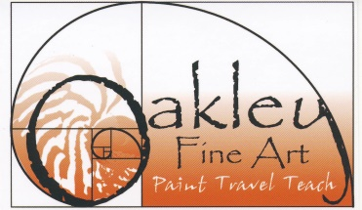
Address: …………………………………………………………………………………………………….......................................
State: ………………………………………………………………………… Postcode: …………………………..
Email: ……………………………………………………………………………… Mobile/Phone : …………………………………..

Please circle the workshop/s that you would like to attend. You can bulk book or do one at a time.

7. Landscapes in Oil Oil Sun 23 Apr Hahndorf Academy Studio 9-3 $65
8. Artists Who Coffee Pen and Wash Fri 27 Apr Hahndorf Café TBA 10-12 $20 (includes coffee and treats)
9. Waterscapes Pastel & mixed media Sat 28 Apr Hahndorf Academy Studio 9 -3 $65
10. Demonstration and Auction Pastel Sun 29 Apr Hahndorf Academy Exhibition 9-3 Gold Coin Donation to HAA
11. Artists Who Coffee Pen & Wash Fri 4 May Hahndorf Café TBA 10-12 $20 (includes coffee and treats)
12. Still Life Freestyle Pastel & Mixed Media Sat 5 May Hahndorf Academy Studio 9-3 $65
13. Urban Painting and Sketch Oil, Pastel, Pen & Wash Sun 6 May Hahndorf Academy grounds 9-12 $20 (demonstration/untutored)
14. En Plein-air at The Cedars your choice of medium Thu 10 may The Cedars Heysen Rd, Hahndorf 9:30-2:30 $45 plus entry
15. Artists who Coffee Pen & Wash Fri11 May Hahndorf Café TBA 10-12 $20 (includes coffee and treats)
16. Portraits Pastel/mixed media Sat 12 May Hahndorf Academy Studio 9-3 $65
17. Critique Session all Sun 13 May Hahndorf Academy Exhibition 9-11 NC (for participants of workshops).
18. Demonstration and Auction Pastel Sun 13 May Hahndorf Academy Exhibition 1-3:30 Gold Coin Donation for The Cedars 19. Farewell Exhibition and Friends Sun 13 May Hahndorf Academy Exhibition 4-5 NC

Booking and paying is all through the Hahndorf Academy. A deposit of $10 is required for Artists who Coffee.
Cancellation Policy: All deposits and payments are fully refundable up to 19 April 2018. Cancellations after that are not refunded unless you can find someone to fill your place.
Thank you for your booking I look forward to meeting you at Hahndorf. Best wishes Karol

